Linked List. Normal
- Reverse List In Place
- Insert Elements
- Linked List Cycle
- Merge Sorted Lists
- Intersection of Lists
Linked List. Advanced
- Delete Node
- Nth to Last Element
- Reorder List
- Detect and Remove Loop in a Linked List.
- Merge k Lists
Linked List. Normal
- Reverse List In Place. Implement the reversal of a singly linked list. You should be able to do this in linear time and without allocating additional memory other than pointers.
Possible solution in Java (http://www.programminginterview.com/content/linked-lists):
public class Node {
Node next;
Object data;
public Node(Object data) {
this.data = data;
}
}

Node reverse(Node head) {
Node previous = null;
Node current = head;
Node forward;
while (current != null) {
forward = current.next;
current.next = previous;
previous = current;
current = forward;
}
return previous;
}
This solution assumes that a single linked list is acyclic.
- Insert Elements. Insert an element in order into a sorted linked list containing integer data.

Solution (http://www.programminginterview.com/content/linked-lists)

With two pointers, this problem should boil down to finding the two nodes that the element to be inserted should go between. Two special cases are if the insertion node should be in the head or tail position, and also don’t forget to test for a null head and for the list’s end.

public Node insertInOrder(Node head, Node insert) {
if (head == null)
return null;
Node previous = head;
Node current = head.next;
if (current == null) {
if (previous.data < insert.data) {
previous.next = insert;
insert.next = null;
return head;
}
else {
insert.next = previous;
return insert;
}
}
while (current != null) {
if (previous.data < insert.data && current.data >= insert.data) {
previous.next = insert;
insert.next = current;
return head;
}
current = current.next;
previous = previous.next;
}
current = insert;
insert.next = null;
return head;
}

- Linked List Cycle. Given a linked list, determine if it has a cycle in it.

Solution from http://www.programminginterview.com/content/linked-lists

One idea is to mark nodes that have been seen, either by adding a flag to the node itself or storing information about the node in a separate data structure. Unfortunately, this method requires modification of the node and/or additional space.
Another idea is to advance two pointers at a fixed interval between each other at two different speeds. One pointer will travel at twice the speed of the other, so in an acyclic list, the fast one will reach the end. However, in a cyclic list, both pointers loop endlessly, but the faster pointer will lap the slower pointer at some point, so if the faster pointer ever catches up to the slower pointer, the list has a cycle. To make one pointer “faster” than the other, just advance it two nodes instead of one. However, be aware of null pointers.

public class Node {
Node next;
Object data;
public Node(Object data) {
this.data = data;
}
}
public static boolean hasCycle(Node head) {
Node fast = head;
Node slow = head;
while (fast != null && slow != null && fast.next != null) {
slow = slow.next;
fast = fast.next.next;
if (slow == fast) {
return true;
}
}
return false;
}

The running time for this algorithm is O(n). For the acyclic case, the faster pointer will reach the last node after traversing the entire list. For the cyclic case, the slower pointer will only go around a loop at most once, and the faster pointer will only go through a loop at most twice, so in the worst case 3n nodes are examined, which is still an O(n) algorithm.
Another discussion: http://www.programcreek.com/2012/12/leetcode-linked-list-cycle/

- Merge Sorted Lists. Merge two sorted linked lists and return it as a new sorted list. The new list should be made by splicing together the nodes of the first two lists.
Example: Input A: 5 -> 10 -> 15 B: 2 -> 3 -> 20 Result: 2 -> 3 -> 5 -> 10 -> 15 -> 20
Note: There are many cases to deal with: either list ‘a’ or list ‘b’ may be empty, during processing either list ‘a’ or list ‘b’ may run out first, and finally there’s the problem of starting the result list empty, and building it up while going through lists ‘a’ and ‘b’.

Method 1 (Using Dummy Nodes)
http://www.programcreek.com/2012/12/leetcode-merge-two-sorted-lists-java/
The key to solve the problem is defining a fake head. Then compare the first elements from each list. Add the smaller one to the merged list. Finally, when one of them is empty, simply append it to the merged list, since it is already sorted.
/* Definition for singly-linked list.
* public class ListNode {
* int val;
* ListNode next;
* ListNode(int x) {
* val = x;
* next = null;}
* }
*/
public class Solution {
public ListNode mergeTwoLists(ListNode l1, ListNode l2) {
ListNode p1 = l1;
ListNode p2 = l2;
ListNode fakeHead = new ListNode(0);
ListNode p = fakeHead;
while(p1 != null && p2 != null){
if(p1.val <= p2.val){
p.next = p1;
p1 = p1.next;
}else{
p.next = p2;
p2 = p2.next;
}
p = p.next;
}
if(p1 != null)
p.next = p1;
if(p2 != null)
p.next = p2;
return fakeHead.next;
}
}

Method 2 (Using Local References) http://www.geeksforgeeks.org/merge-two-sorted-linked-lists/
This solution is structurally very similar to the above, but it avoids using a dummy node. Instead, it maintains a struct node** pointer, lastPtrRef, that always points to the last pointer of the result list. This solves the same case that the dummy node did — dealing with the result list when it is empty. If you are trying to build up a list at its tail, either the dummy node or the struct node** “reference” strategy can be used (see Section 1 for details).

Method 3 (Using Recursion)
http://www.geeksforgeeks.org/merge-two-sorted-linked-lists/

- Intersection of Lists. Given two different lists of objects, come up with an efficient solution to find the intersection of the two lists.
Example: Input A: 10->15->4->20 B: 8->4->2->10 Result: 4->10

Solution (from http://www.geeksforgeeks.org/union-and-intersection-of-two-linked-lists/)

Method 1 (Simple)
- Initialize result list as NULL.
- Traverse list1 and look for its each element in list2, if the element is present in list2, then add the element to result.
This method assumes that there are no duplicates in the given lists. Time Complexity: O(mn)

#include<stdio.h>
#include<stdlib.h>
struct node /* Link list node */
{
int data;
struct node* next;
};
/* A utility function to insert a node at the beginning of a linked list*/
void push (struct node** head_ref, int new_data);
/* A utility function to check if given data is present in a list */
bool isPresent (struct node *head, int data);
/* Function to get union of two linked lists head1 and head2 */
struct node *getUnion (struct node *head1, struct node *head2)
{
struct node *result = NULL;
struct node *t1 = head1, *t2 = head2;
while (t1 != NULL) // Insert all elements of list1 to the result list
{
push(&result, t1->data);
t1 = t1->next;}
while (t2 != NULL) // Insert those elements of list2 which are not present in result list
{
if (!isPresent(result, t2->data))
push(&result, t2->data);
t2 = t2->next;}
return result;}
Method 2 (Use Merge Sort)

- Sort the first Linked List using merge sort. Refer the problem above for details of this step.
  - If head is NULL or there is only one element in the Linked List, then return.
  - Else divide the linked list into two halves.
FrontBackSplit(head, &a, &b); /* a and b are two halves */
  - Sort the two halves a and b.
MergeSort(a);
MergeSort(b);
  - Merge the sorted a and b (using SortedMerge() discussed above) and update the head pointer
- Sort the second Linked List using merge sort.
- Linearly scan both sorted lists to get the union.

Time complexity of this method is O(mLogm + nLogn)

Method 3 (Use Hashing)
- Initialize the result list as NULL and create an empty hash table.
- Traverse list1.
  - For each element being visited in list1, insert the element in hash table.
- Traverse list2, for each element being visited in list2, look the element in hash table.
  - If the element is present, then insert the element to result list.
  - If the element is not present, then ignore it.

The method assumes that there are no duplicates.
Time complexity of this method depends on the hashing technique used and the distribution of elements in input lists. In practical, this approach may turn out to be better than above 2 methods.
Linked List. Advanced
- Delete Node. Implement an algorithm to delete a node in the middle of a singly linked list, given only access to that node.
Example: Input: The node ‘x’ from the linked list v->w->x->y->z Result: Nothing is returned, but the new linked list looks like v->w->y->z

Possible solution in Java:
(http://www.programmerinterview.com/index.php/data-structures/delete-a-node-in-the-middle-of-a-singly-linked-list/)

- First we change the data in node X (the node that needs to be deleted) so that it essentially becomes node Y (the node right after it)
- Then we delete the original Y node
- And finally, we set our 'new' Y node to point to the Z node so that the list is back in correct order

public boolean deleteMiddleNode(Node middleNode)
{
//error check:
if (middleNode == null || middleNode.next == null)
return false;
/*middleNode is x in our example data above, but
is now changed to hold the data of node y:
*/
middleNode.data = middleNode.next.data;
//tempNode now holds node z if following the example above:
Node tempNode = middleNode.next.next;
//delete the old node Y from example above
// Nothing points to this node now, it will garbage collected in Java
/*reset pointer so that the new "y" point to z*/
middleNode.next = tempNode;
}

- Nth to Last Element. Implement an algorithm to find the nth to last element of a singly linked list.

Method 1
The naïve solution is to go through the entire linked list first, tallying the number of nodes so that you get the total, and then find nth to last by subtracting n from total. Then, traverse starting from the head again, counting until you reach nth to last.
However, this algorithm requires 2 passes through the linked list – can we do it in less?
Another idea might be to store the last n nodes seen, but this requires extra memory especially as n gets large.

Method 2
Since you’re only interested in the nth from last element, we can create another pointer to the head after the original pointer has traversed n nodes. Then, increment both pointers until the current pointer reaches the end of the list – at that time the behind pointer will be pointing to the nth from last node!

Are there any special cases to be aware of? As always, be aware of the possibilities of null pointers; you should account for the case where n is greater than the length of the list.

Node nthToLast(Node head, int n) {
Node lead = head;
Node chase = head;
for (int i = 0; i < n; i++) {
if (lead == null)
return null;
else
lead = lead.next;
}
while (lead.next != null) {
lead = lead.next;
chase = chase.next;
}
return chase;
}

- Reorder List. Given a singly linked list L: L0→L1→ ... →Ln-1→Ln, reorder it to: L0→Ln→L1→Ln-1→L2→Ln-2→… You must do this in-place without altering the nodes' values. Example: A {1,2,3,4} Result: {1,4,2,3}.
Solution(http://www.programcreek.com/2013/12/in-place-reorder-a-singly-linked-list-in-java/)
This problem requires "in-place" operations. That means we can only change their pointers, not creating a new list.

- Break list in the middle to two lists (use fast & slow pointers)
- Reverse the order of the second list (see 1st image)
- Merge two list back together (see 2nd image)

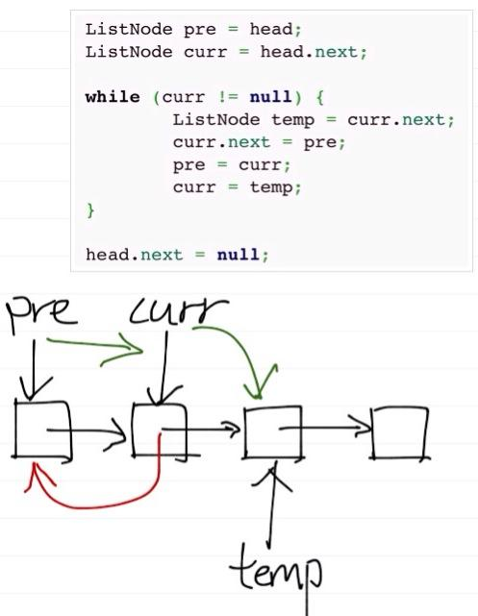 | 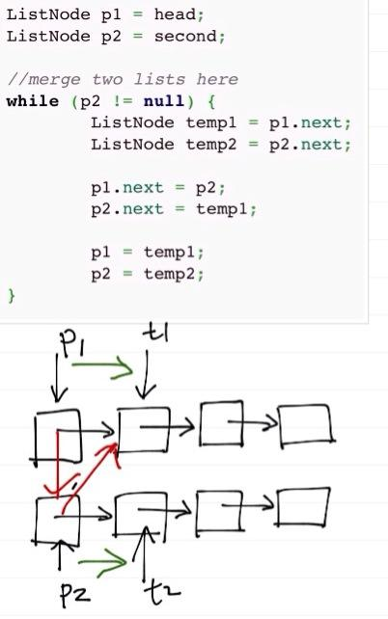

- Detect and Remove Loop in a Linked List. Write a function detectAndRemoveLoop() that checks whether a given Linked List contains loop and if loop is present then removes the loop and returns true. And if the list doesn’t contain loop then returns false.
Example: Below diagram shows a linked list with a loop. detectAndRemoveLoop() must change the below list to 1->2->3->4->5->NULL.
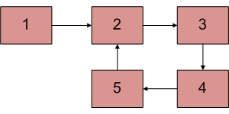

Before trying to remove the loop, we must detect it. To remove loop, all we need to do is to get pointer to the last node of the loop. Once we have pointer to the last node(5 in the above diagram), we can make the next of this node as NULL and loop is gone.
We can easily use Hashing or Visited node techniques to get the pointer to the last node. Idea is simple: the very first node whose next is already visited (or hashed) is the last node.
We can also use Floyd’s Cycle Detection algorithm to detect and remove the loop. In the Floyd’s algo, the slow and fast pointers meet at a loop node. We can use this loop node to remove cycle. There are following two different ways of removing loop when Floyd’s algorithm is used for Loop detection.

Method 1 (Check one by one)
We know that Floyd’s Cycle detection algorithm terminates when fast and slow pointers meet at a common point. We also know that this common point is one of the loop nodes (2 or 3 or 4 or 5 in the above diagram). We store the address of this in a pointer variable say ptr2. Then we start from the head of the Linked List and check for nodes one by one if they are reachable from ptr2. When we find a node that is reachable, we know that this node is the starting node of the loop in Linked List and we can get pointer to the previous of this node.

Method 2
This method is also dependent on Floyd’s Cycle detection algorithm.
1) Detect Loop using Floyd’s Cycle detection algo and get the pointer to a loop node.
2) Count the number of nodes in loop. Let the count be k.
3) Fix one pointer to the head and another to kth node from head.
4) Move both pointers at the same pace, they will meet at loop starting node.
5) Get pointer to the last node of loop and make next of it as NULL

- Merge k Lists. Write an algorithm to merge k sorted lists into one sorted list where n is the total number of elements in all the input lists. Analyze and describe its complexity.

The simplest solution is using PriorityQueue. The elements of the priority queue are ordered according to their natural ordering, or by a comparator provided at the construction time (in this case).
Possible Jave Solution
import java.util.ArrayList;
import java.util.Comparator;
import java.util.PriorityQueue;
// Definition for singly-linked list.
class ListNode {
int val;
ListNode next;
ListNode(int x) {
val = x;
next = null;
}
}
public class Solution {
public ListNode mergeKLists(ArrayList<ListNode> lists) {
if (lists.size() == 0)
return null;
//PriorityQueue is a sorted queue
PriorityQueue<ListNode> q = new PriorityQueue<ListNode>(lists.size(),
new Comparator<ListNode>() {
public int compare(ListNode a, ListNode b) {
if (a.val > b.val)
return 1;
else if(a.val == b.val)
return 0;
else
return -1;
}
});
//add first node of each list to the queue
for (ListNode list : lists) {
if (list != null)
q.add(list);
}
ListNode head = new ListNode(0);
ListNode p = head; // serve as a pointer/cursor
while (q.size() > 0) {
ListNode temp = q.poll();
//poll() retrieves and removes the head of the queue - q.
p.next = temp;
//keep adding next element of each list
if (temp.next != null)
q.add(temp.next);
p = p.next;
}
return head.next;
}
}

Time: log(k) * n where k is number of list and n is number of total elements.

